SMIC 2018, 2-4 November 2018
Lumire Hotel and Convention Centre

General Information
Dear SMIC 2018 participants,
Due to our SMIC agenda is getting closer, we are looking forward to meeting you, greeting you, and offering an engaging space for our three days together as a participant of Science and Matemathics International Conference (SMIC) 2018.
Please have a time to read the detail information about the SMIC which may answer your question about final preparation for attendance and participants.
2 November 2018 Opening Ceremony, Main Conference, and Workshop (Lumire Hotel & Convention Center 4th floor, Central Jakarta)
3 – 4 November 2018 (Main Conference) (Lumire Hotel & Convention Center 4th floor, Central Jakarta)
Registration will be situated on 4th floor of the hotel during the following time : 08.00-16.00, Friday to Sunday, November 2-3, 2018.
Polite request to all participants to arrive in a timely fashion for all adresses.
Presenters are reminded that the time slots should be divided fairly and equally by the numbers of presentation and that they should not overrun. The session chair is asked to assume this timekeeping role and to summarize key issue in each topic.
Oral presenters are kindly invited to submit their presentation on registration desk prior to peesonal registration.
All presentation room are equipped with a screen, LCD projector and a laptop . We recommend you to prepare and double check your presentation file in power Point which has been submitted on registration desk before your session start.
Certificate of oral or poster presentation will include participant’s name and paper tittle, workshop will include name and workshop duration.
Certificate distribution of oral presenter will be given after SMIC closing. Certificate of workshop participants will be after workshop.

Venue of Conference
The conference will be held in the Conference Hall, located inside Lumire Hotel & Convention Center, Central Jakarta, 4th floor. (http://www.lumirehotel.com/default-en.html)
The address: Jalan Senen Raya No.135, Jakarta 10410, Indonesia
Time Zone: UTC/GMT +7 hours
Telephone Area Code: Jakarta +6221, Jakarta.
Average Temperature
Early November, the highest temperature in Jakarta is 31 degrees celcius (87.8 Farenheit). the lowest temperature in Jakarta is 24 degrees celcius (75.2 Farenheit). The average of the temperature in jakarta is 27.5 degrees celcius (81.5 Farenheit).

If you stay hotel nearby (IBIS Senen and Cordela Hotel), you can walk by to the venue. Please inform our team if you need any help

Meals
All breakfasts and lunches from 2 November to 4 November will be served at Lumire Hotel near the Conference Hall. Participant meat have all the meal without any expenses (Free meals for all conference day).

Travel Planning
Plan to arrive: 1 November
Plan to depart: Not earlier than Sunday late afternoon 4 November because the closing ceremony will end at 5 and a half p.m.
If you can add a day on either end to enjoy Jakarta or neighbouring cities, you should have your time in Jakarta longer.
Note that paid taxis take about 40-60 minutes to get to Lumire Hotels & Convention Center from airport, depend on the traffic.
Please send us your travel details; our volunteers will welcome you at the airport and help you catch a taxi (you need to pay the taxi fare on your own) to get to your respective hotel or directly to the conference venue. There are terminal 2 and 3 for international delegates. Our volunteers will be there right at the exit of international arrivals with a Conference Sign Card (SMIC 2018). Our personal contact will coordinating your travel from airport to hotel. You may add our volunteer manager (Phone +62 852-8725-2124, Mr. Yoriza) onto your Whatsapp contact in case you do not see any volunteer nerby the airport. The personal contact will manage volunteers or him/herself to meet you.
If by any chance, our volunteers cannot catch you, you may book the prepaid taxi wich is available at the airport by yoursef. Once you step out of the arrival gate the prepaid taxi service is really close to your right. Tell them that you need to go to Lumire Hotel & Convention Center, Jalan Senen Raya No.135, Jakarta 10410, Indonesia.
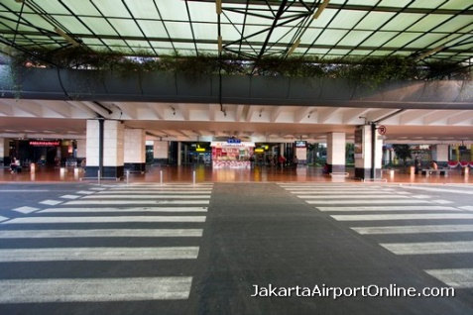
Soekarno Hatta Jakarta International Airport, Terminal 2. Photo by: http://www.jakartaairportonline.com

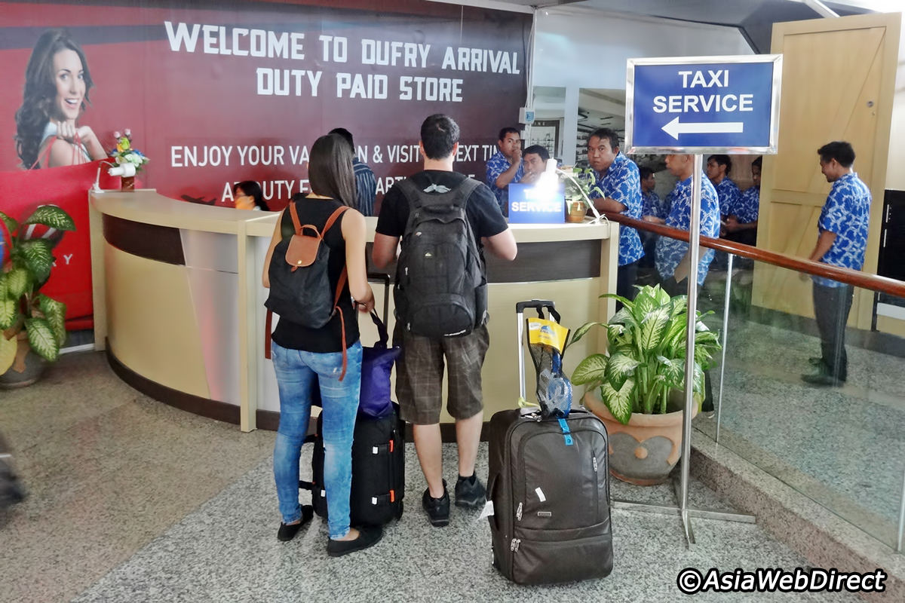

Prepaid Taxi Service at Soekarno Hatta Jakarta International Airport. Photo by: http://www.jakartaairportonline.com

